# Revision History

**Revision History identify changes to the Design Document.**

|  |  |  |  |
| --- | --- | --- | --- |
| **Name** | **Date** | **Description** | **Version** |
| Mosys repair | **11/11/16** | Repair system for mobile phone | Version 1.0 |
|  |  |  |  |

# Use Case Overview

**Use Case Diagram Level 0: MosysRepair system**



## **Use Case Diagram Level 1: Repairs Management Sub-System (UC100)**

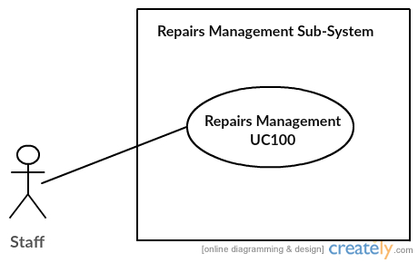

Miss Uraiwan Puekphet 5730213031

**Use Case Diagram Level 1: Divice’s Management Sub-System (UC200)**

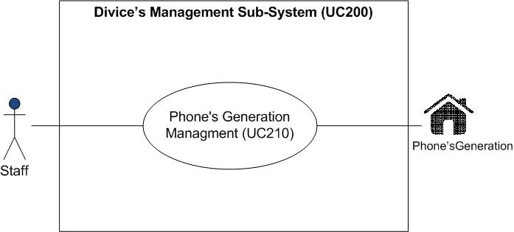

MissPuttinun Duangsamran 5730213038

**Use Case Diagram Level 1: Show Information Sub-System (UC300)**

**jasadaporn-usecaselv1**

**Show Information Sub-System (UC300)**

Mr.Jasadaporn Sain-Un 5730213073

**Use Case Diagram Level 1: Personal’s Management Sub-System (UC400)**

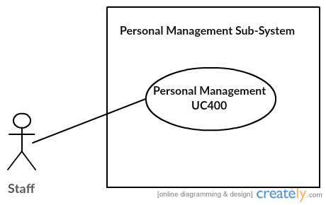

## Mr.Sitta Chumklaew 5730213074

**Use case Diagram LV1: Shop and Bill (UC500)**

**Bill**

Mr.Tanawat Meechai 5730213080

**Use Case Diagram Level 1: Report Sub-System (UC600)**

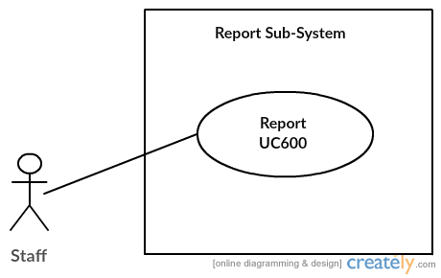

Mr.Pasin Sommung 5730213096

## **Use Case Diagram Level 2: Repairs Management Sub-System (UC100)**

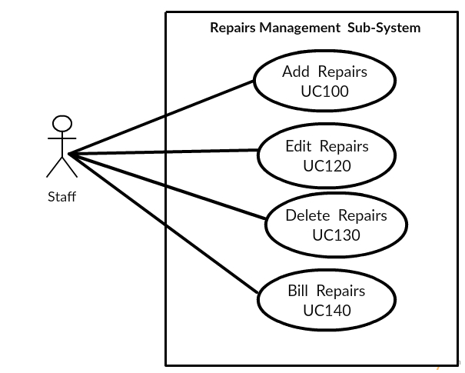

Miss Uraiwan Puekphet 5730213031

**Use Case Diagram Level 2 : Phone’s Generation Management (UC210)**

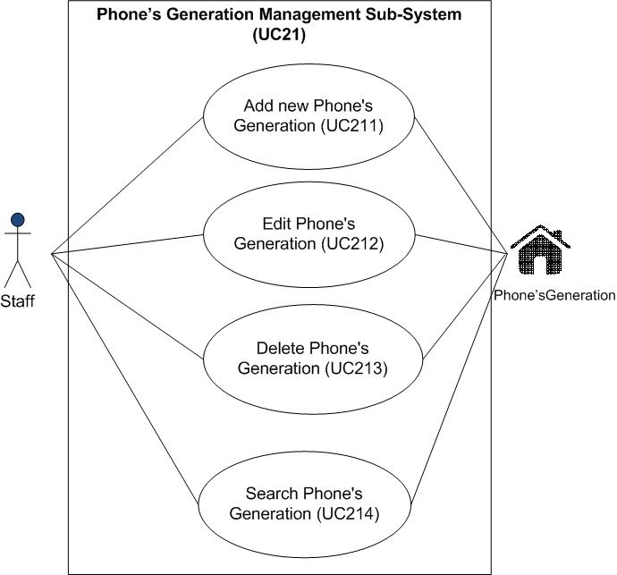

MissPuttinun Duangsamran 5730213038

**Use Case Diagram Level 2 : Show Information (UC300)**

**jasadaporn-usecaselv2**

Mr.Jasadaporn Sain-Un 5730213073

**Use Case Diagram Level 2: Personal’s Management Sub-System (UC400)**

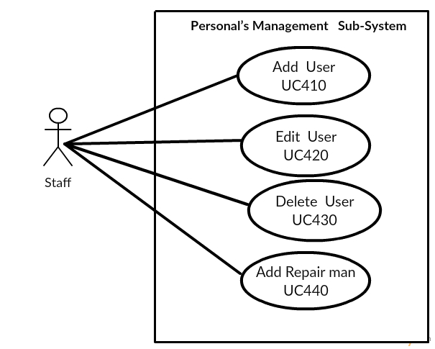

Mr.Sitta Chumklaew 5730213074

**Use case Diagram LV2 : Bill Management (UC510)**

**ucLv2Bill**

Mr.Tanawat Meechai 5730213080

**Use case LV2 : Shop Management (UC520)**

**ucLv2shop (1)**

Mr.Tanawat Meechai 5730213080

**Use Case Diagram Level 2 : Report Sub-System**

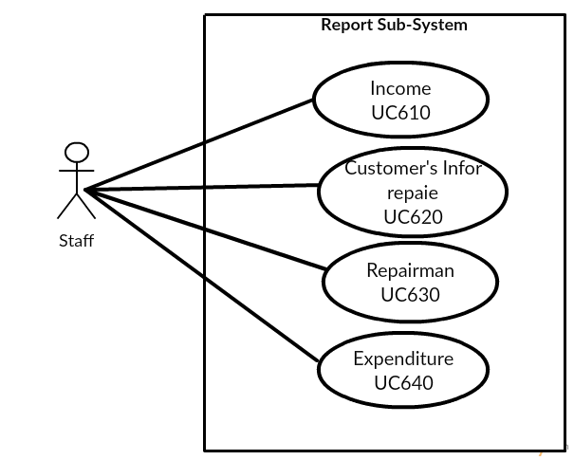

Mr.Pasin Sommung 5730213096

# 3.System Structure



# 4. Static Structure and Data Analysis

**4.1 Model-View-Controller (MVC) Model**

MVC Add Repairs

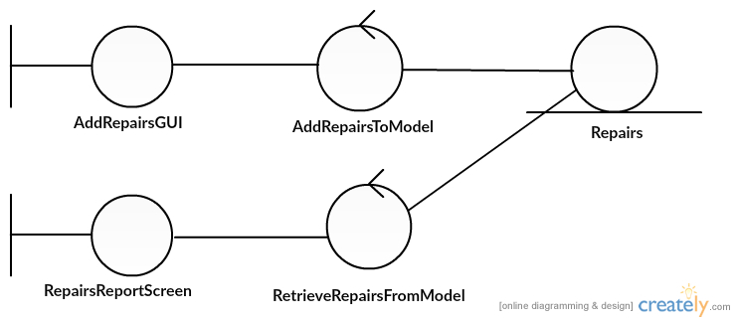

Miss Uraiwan Puekphet 5730213031

MVC Edit Repairs

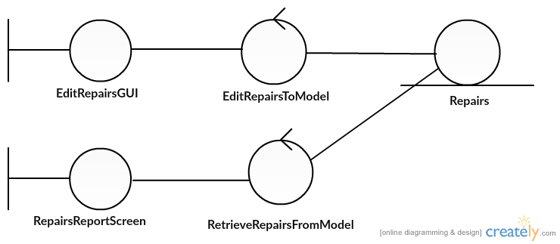

Miss Uraiwan Puekphet 5730213031

MVC Delete Repairs

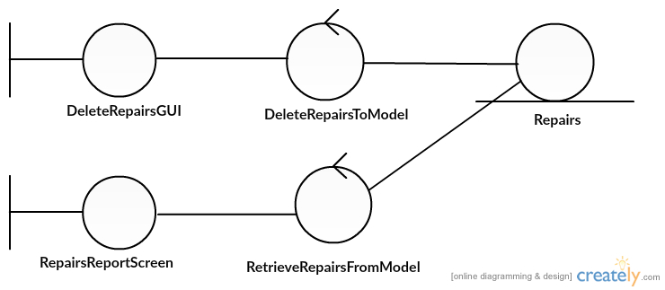

Miss Uraiwan Puekphet 5730213031

MVC Print bill Repairs

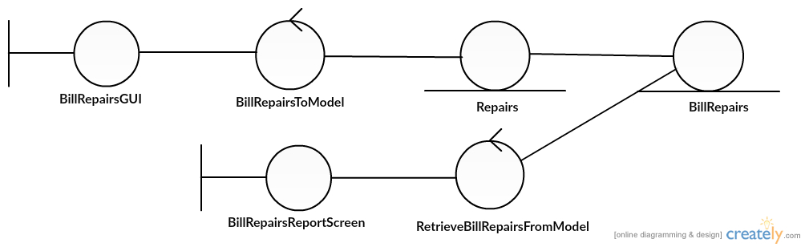

Miss Uraiwan Puekphet 5730213031

MVC Add Phone’s Generation

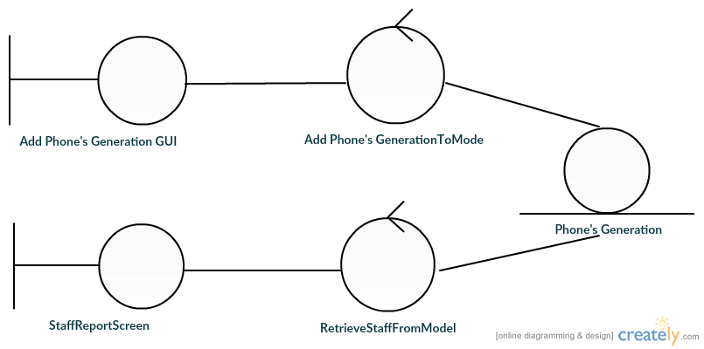

MissPuttinun Duangsamran 5730213038

MVC Edit Phone’s Generation

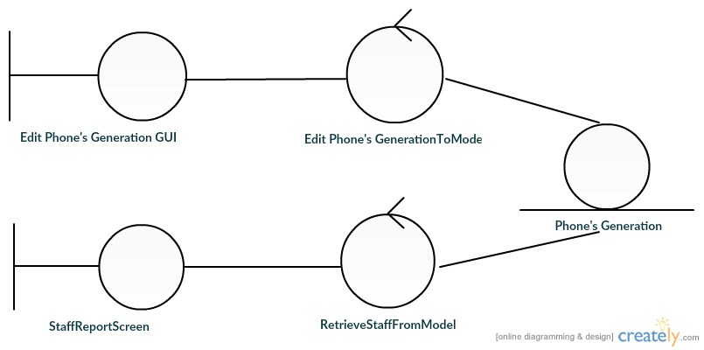

MissPuttinun Duangsamran 5730213038

MVC Delete Phone’s Generation

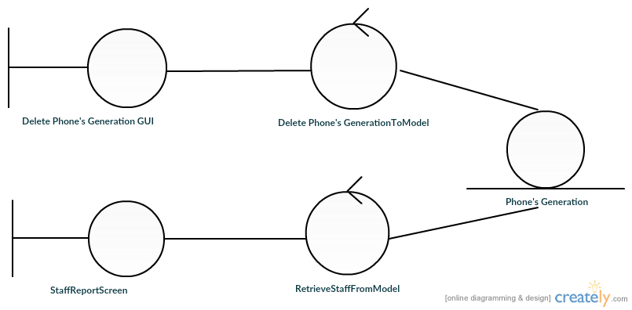

MissPuttinun Duangsamran 5730213038

MVC Search Phone’s Generation

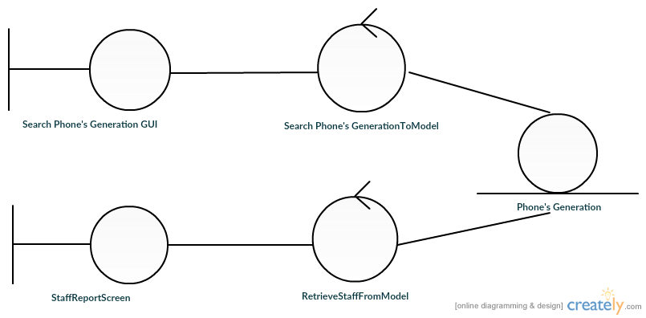

MissPuttinun Duangsamran 5730213038

**MVC** Show customer take back

**1**

Mr.Jasadaporn Sain-Un 5730213073

MVCShow turn to customer

**2**

Mr.Jasadaporn Sain-Un 5730213073

MVC Show wait for repair

**3**

Mr.Jasadaporn Sain-Un 5730213073

**MVC** Show repair is done

4

Mr.Jasadaporn Sain-Un 5730213073

MVC Show take to repair center

**C:\Users\DELL\AppData\Local\Microsoft\Windows\INetCache\Content.Word\Mvc take to repair.png**

Mr.Jasadaporn Sain-Un 5730213073

MVC Add User

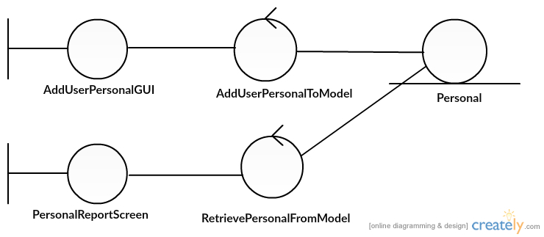

Mr.Sitta Chumklaew 5730213074

MVC Edit User

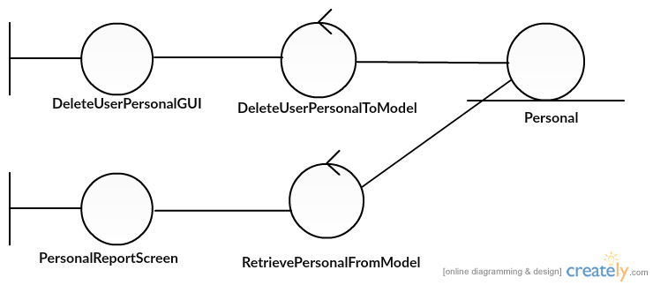

Mr.Sitta Chumklaew 5730213074

MVC Delete User

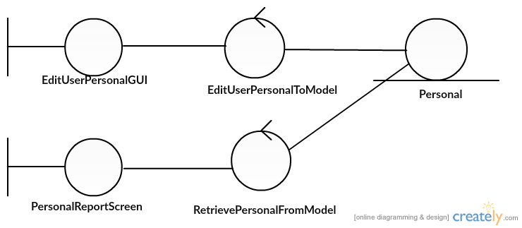

Mr.Sitta Chumklaew 5730213074

MVC Add Repairman

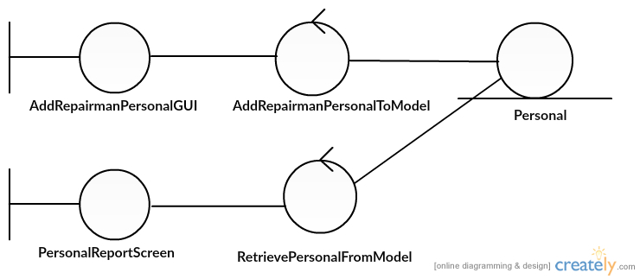

Mr.Sitta Chumklaew 5730213074

**Bill Management**



Mr.Tanawat Meechai 5730213080



Mr.Tanawat Meechai 5730213080



Mr.Tanawat Meechai 5730213080

**Shop Management**



Mr.Tanawat Meechai 5730213080



Mr.Tanawat Meechai 5730213080

MVC Income

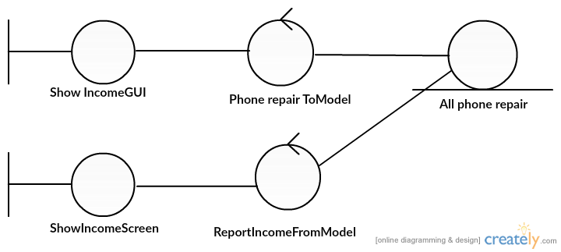

Mr.Pasin Sommung 5730213096

MVC Customer’s info. As Repair

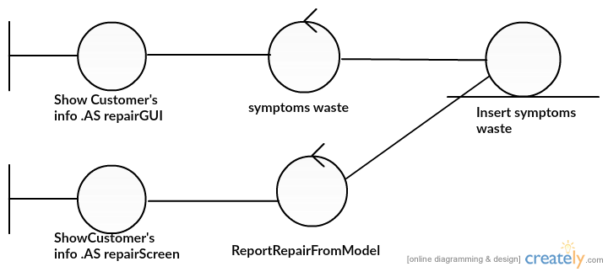

Mr.Pasin Sommung 5730213096

MVC Repairman

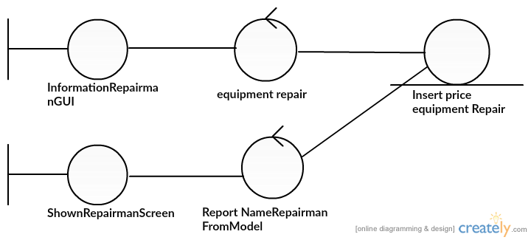

Mr.Pasin Sommung 5730213096

MVC Expenditure

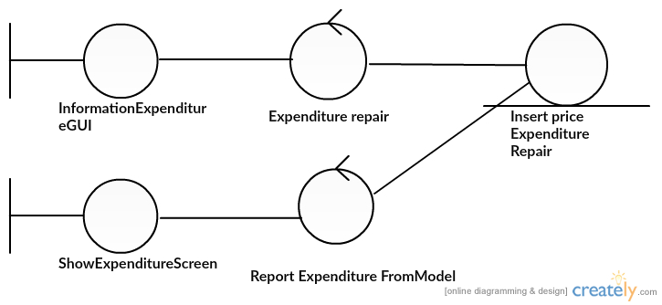

Mr.Pasin Sommung 5730213096

**4.2Class Diagram**



**5.System Behaviour Model**

**Sequence Diagram demonstrating operation “add, update, delete, bill repairs”**

* This diagram describes the system scenario of “UC110: Add Repairs”

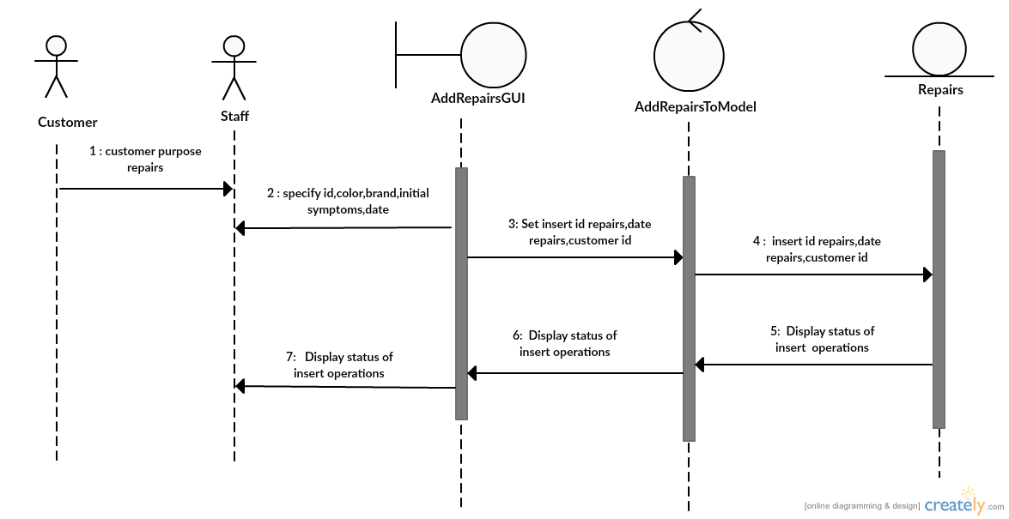

Miss Uraiwan Puekphet 5730213031

* This diagram describes the system scenario of “UC120: Edit Repairs”

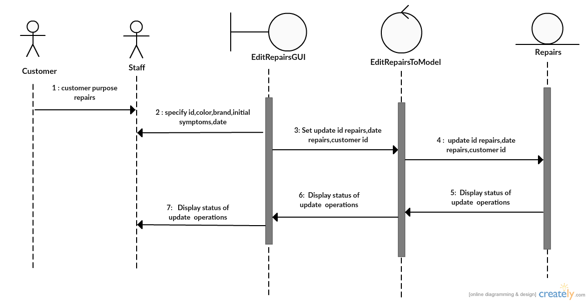

Miss Uraiwan Puekphet 5730213031

* This diagram describes the system scenario of “UC130:Delete Repairs”

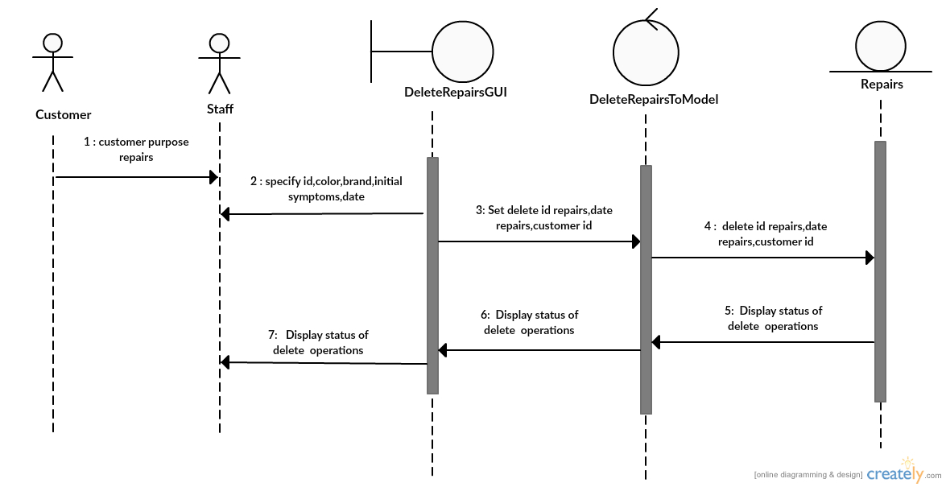

Miss Uraiwan Puekphet 5730213031

* This diagram describes the system scenario of “UC140:Bill Repairs”

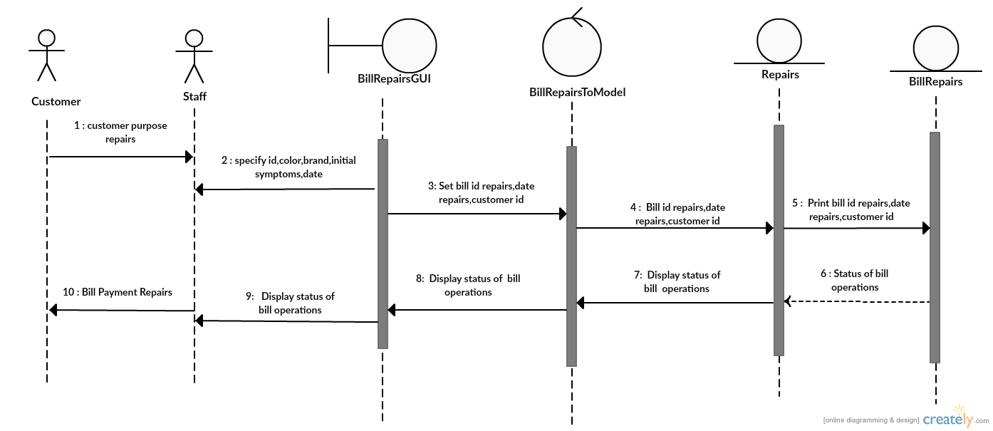

Miss Uraiwan Puekphet 5730213031

**Sequence Diagram demonstrating operation “add new Phone’s Generation”**

* This diagram describes the system scenario of **“UC211: Add new Phone’s Generation”**

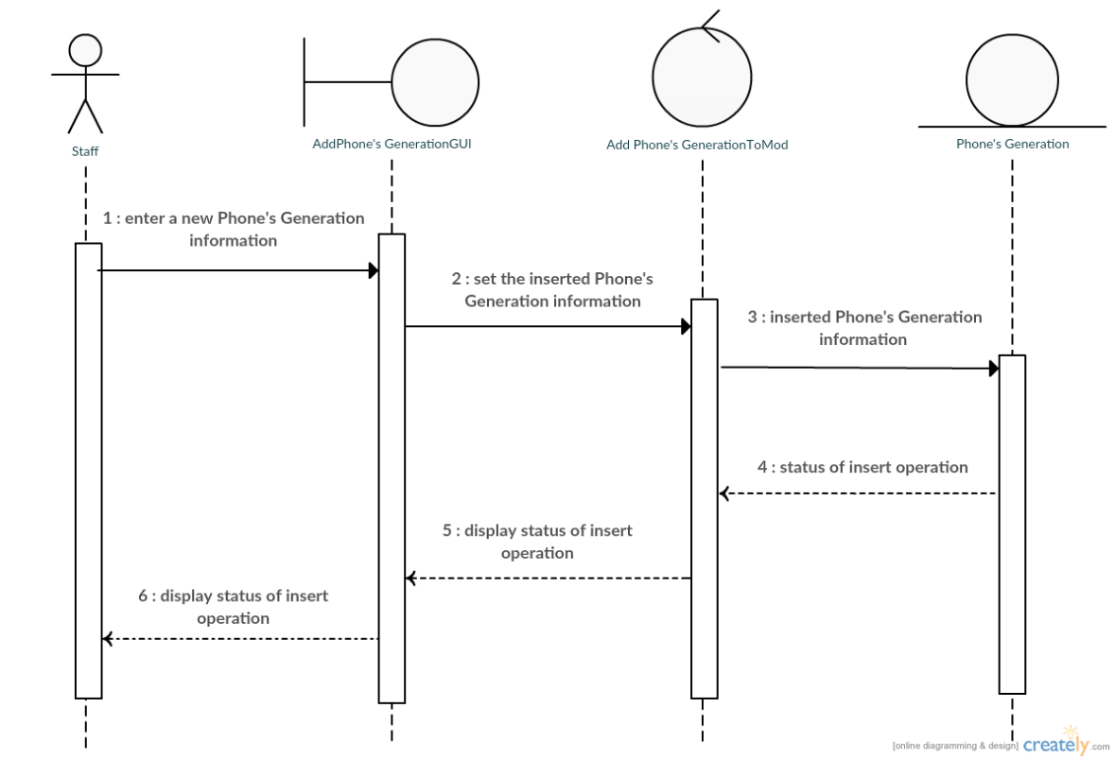

MissPuttinun Duangsamran 5730213038

**Sequence Diagram demonstrating operation “update Phone’s Generation”**

* This diagram describes the system scenario of **“UC212: Edit Phone’s Generation”**

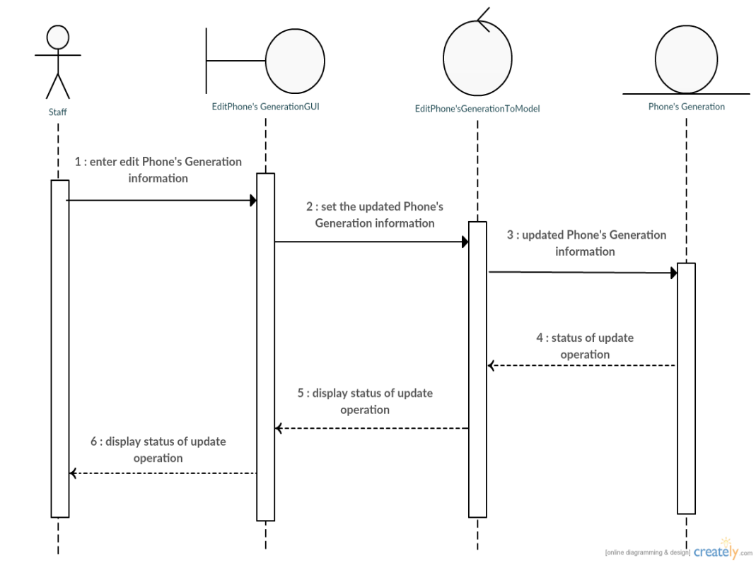

MissPuttinun Duangsamran 5730213038

**Sequence Diagram demonstrating operation “delete Phone’s Generation”**

* This diagram describes the system scenario of **“UC213: Delete Phone’s Generation”**

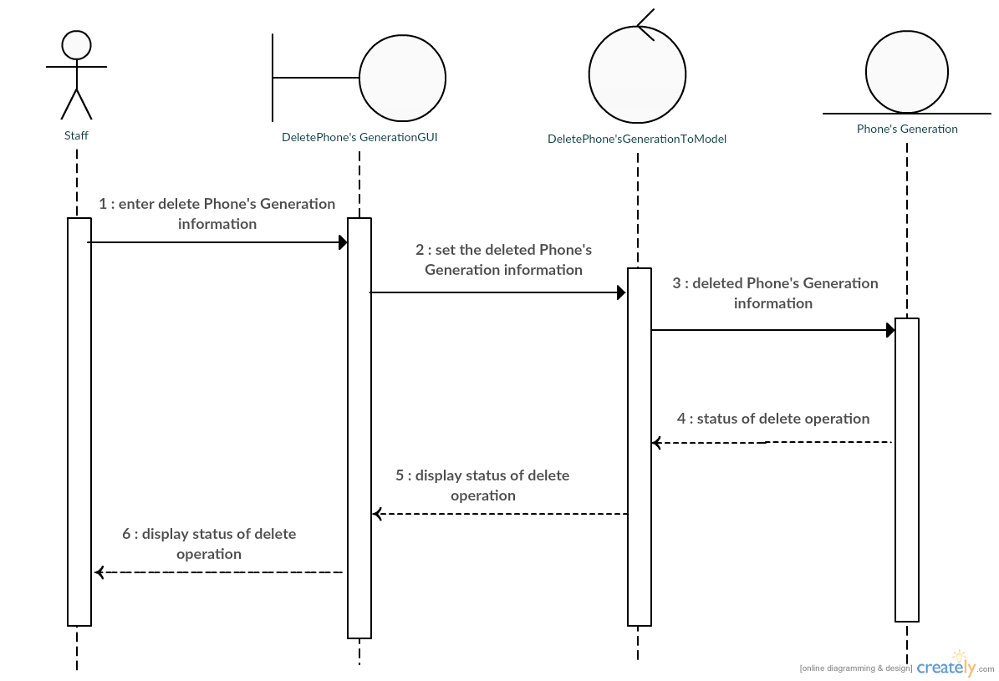

MissPuttinun Duangsamran 5730213038

**Sequence Diagram demonstrating operation “search Phone’s Generation”**

* This diagram describes the system scenario of **“UC214: Search Phone’s Generation”**

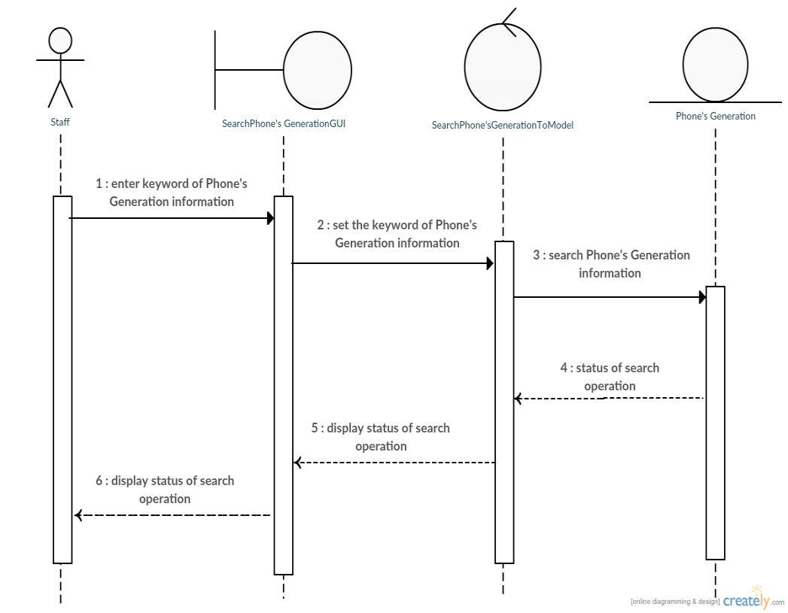

MissPuttinun Duangsamran 5730213038

**Sequence Diagram demonstrating operation “show customer take back”**

* This diagram describes the system scenario of **“UC310: show customer take back”**

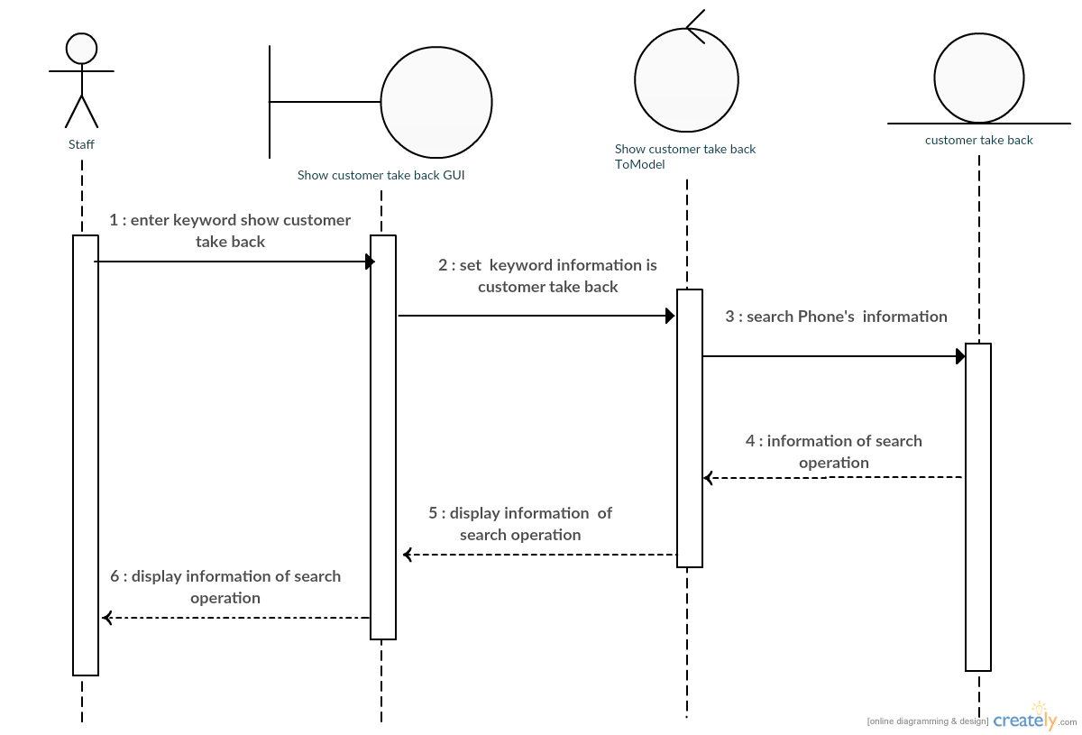

Mr.Jasadaporn Sain-Un 5730213073

**Sequence Diagram demonstrating operation “turn back to customer”**

* This diagram describes the system scenario of **“UC320: turn back to customer”**

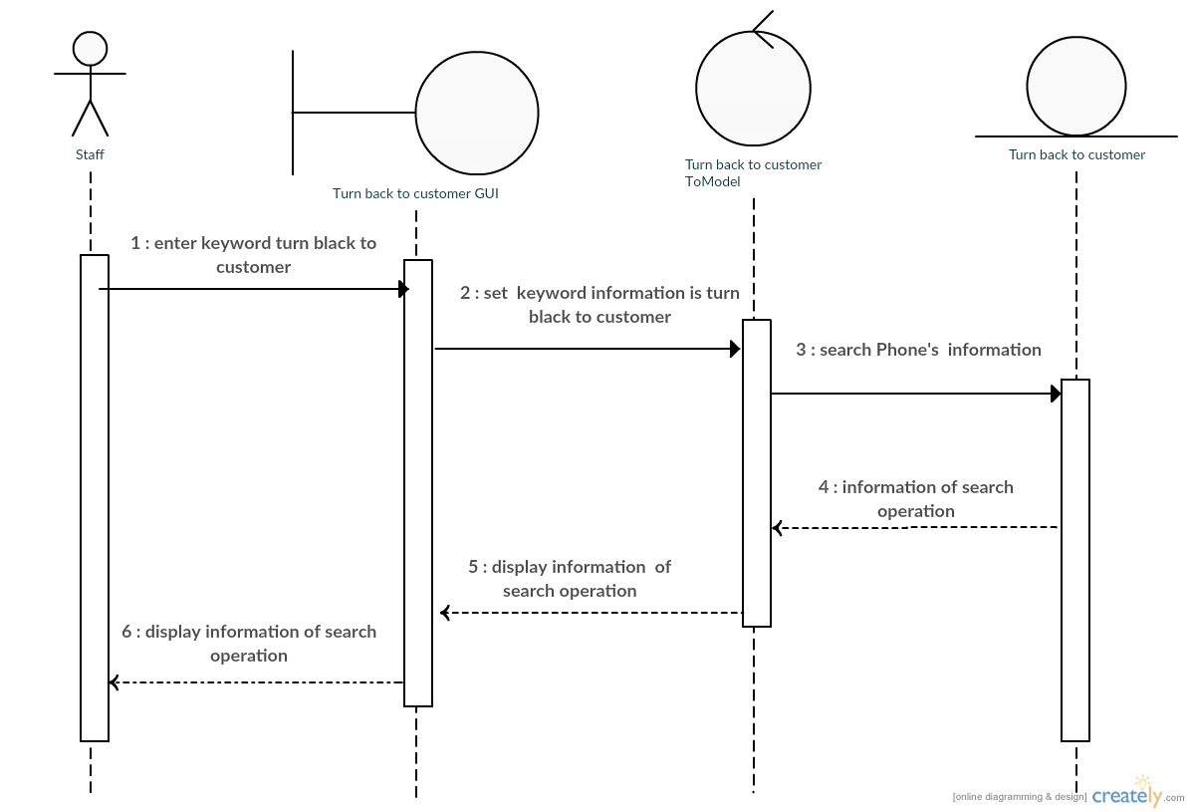

Mr.Jasadaporn Sain-Un 5730213073

**Sequence Diagram demonstrating operation “waiting for repair”**

* This diagram describes the system scenario of **“UC330: waiting for repair”**

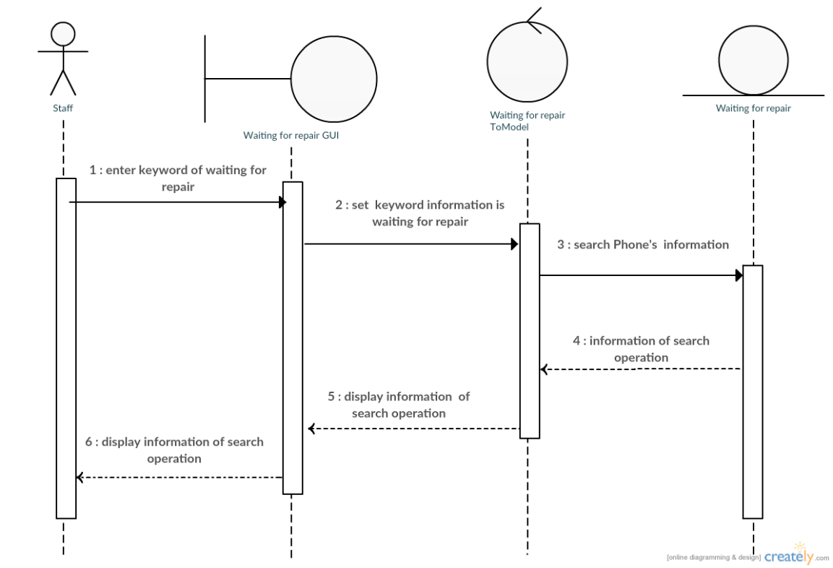

Mr.Jasadaporn Sain-Un 5730213073

**Sequence Diagram demonstrating operation “repair is done”**

* This diagram describes the system scenario of **“UC340: repair is done”**

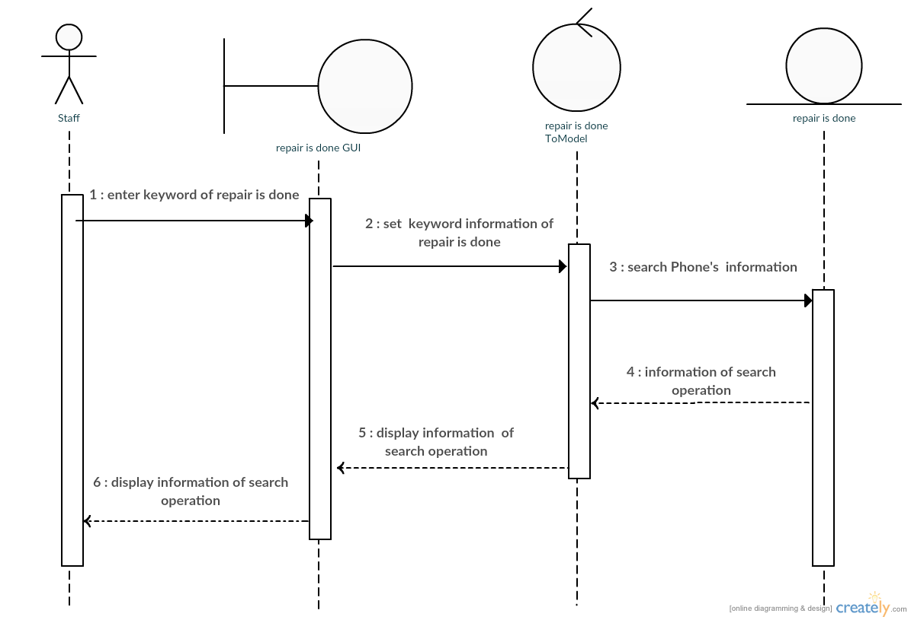

Mr.Jasadaporn Sain-Un 5730213073

**Sequence Diagram demonstrating operation “Take to repair canter”**

* This diagram describes the system scenario of **“UC350: Take to repair canter”**

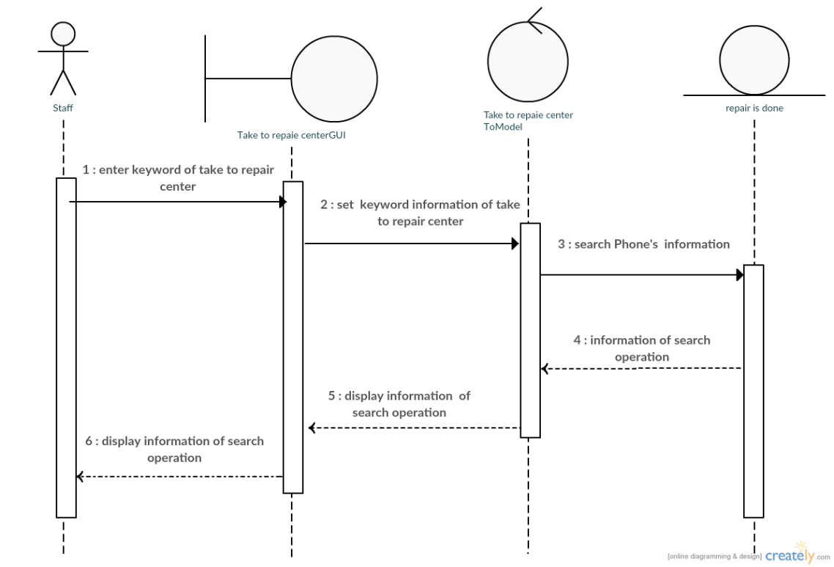

Mr.Jasadaporn Sain-Un 5730213073

**Sequence Diagram demonstrating operation “Add User, Edit User, Delete User,Add repairman”**

* 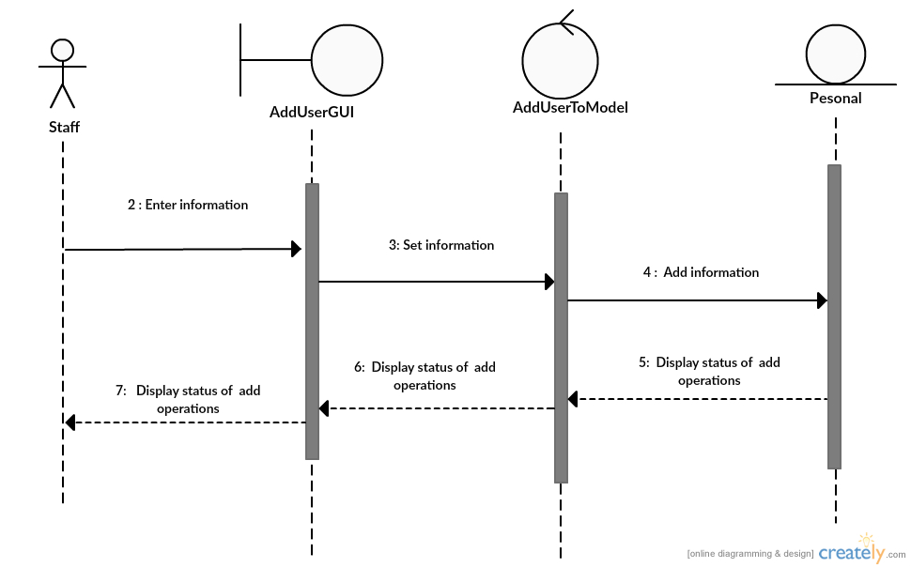This diagram describes the system scenario of “UC410: Add User”

Mr.Sitta Chumklaew 5730213074

* 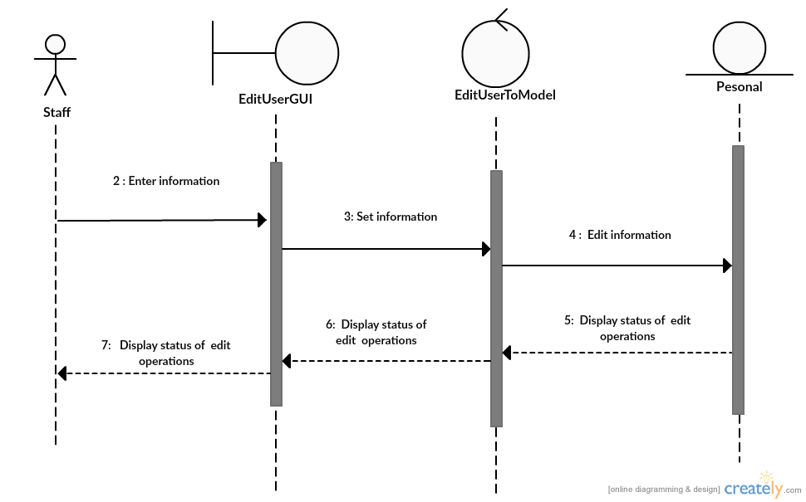This diagram describes the system scenario of “UC420: Edit User”

Mr.Sitta Chumklaew 5730213074

* 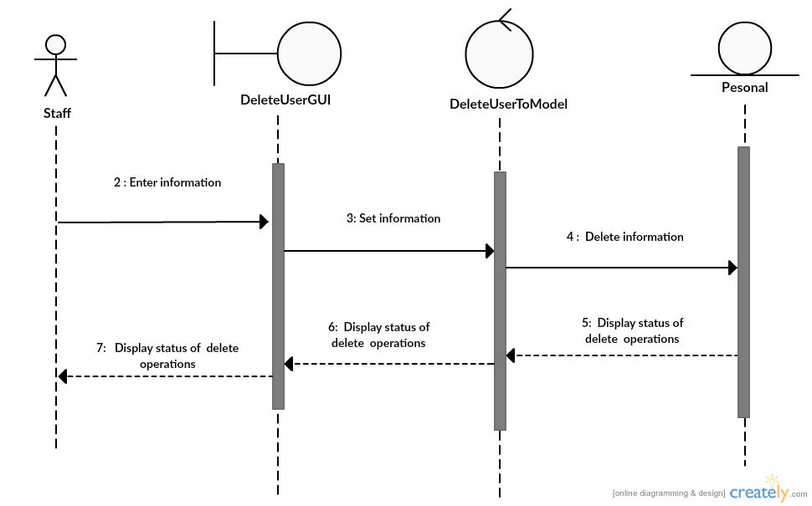This diagram describes the system scenario of “UC430:Delete User”

Mr.Sitta Chumklaew 5730213074

* 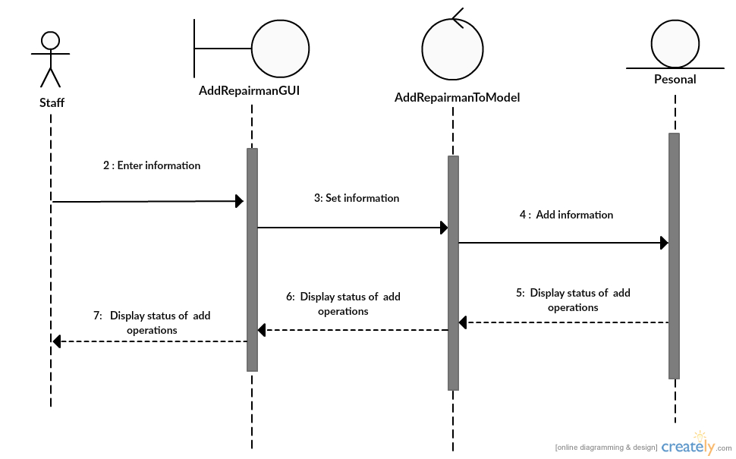This diagram describes the system scenario of “UC440:Bill Repairs”

Mr.Sitta Chumklaew 5730213074

**Sequence Diagram demonstrating operation “add Bill”**

* This diagram describes the system scenario of **“UC511: Add Bill”**



Mr.Tanawat Meechai 5730213080

**Sequence Diagram demonstrating operation “Update Bill”**

* This diagram describes the system scenario of **“UC512: Update Bill”**



Mr.Tanawat Meechai 5730213080

**Sequence Diagram demonstrating operation “Search Bill”**

* This diagram describes the system scenario of **“UC513: Search Bill”**



Mr.Tanawat Meechai 5730213080

**Sequence Diagram demonstrating operation “Add About Shop”**

* This diagram describes the system scenario of **“UC521: Add About Shop”**



Mr.Tanawat Meechai 5730213080

**Sequence Diagram demonstrating operation “Update About Shop”**

* This diagram describes the system scenario of **“UC522: Update About Shop”**



Mr.Tanawat Meechai 5730213080

**Sequence Diagram demonstrating operation “In come”**

* This diagram describes the system scenario of **“UC611: Income”**

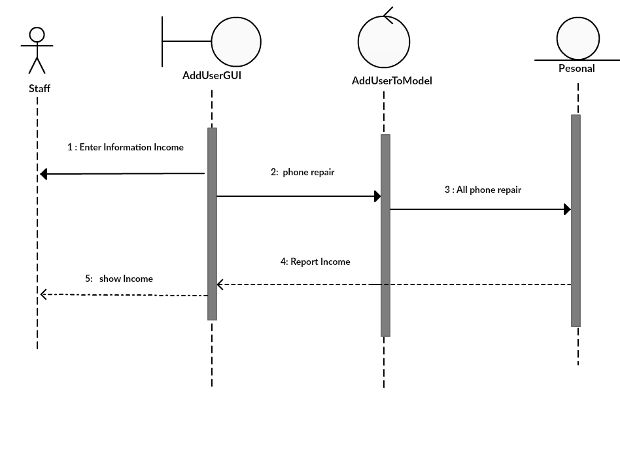

Mr.Pasin Sommung 5730213096

**Sequence Diagram demonstrating operation “Customer’s Info. As Repair”**

* This diagram describes the system scenario of **“UC612:Customer’s Info. As Repair ”**

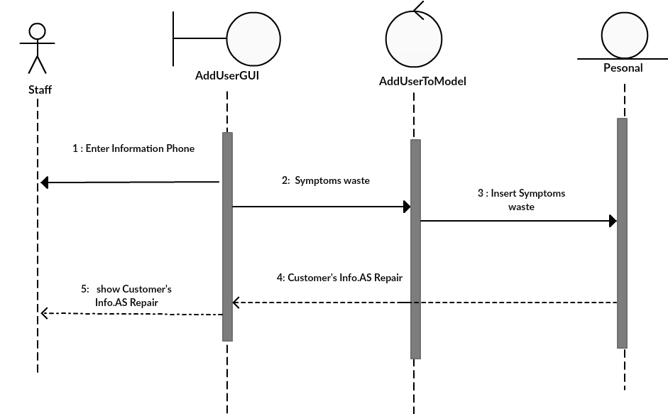

Mr.Pasin Sommung 5730213096

**Sequence Diagram demonstrating operation “Repairman”**

* This diagram describes the system scenario of **“UC613: Repairman”**

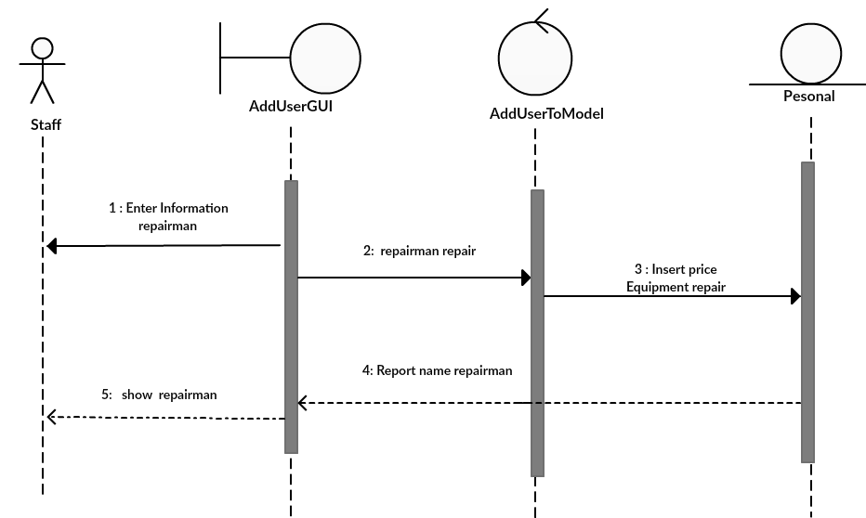

Mr.Pasin Sommung 5730213096

**Sequence Diagram demonstrating operation “expenditure”**

* This diagram describes the system scenario of **“UC614: expenditure”**

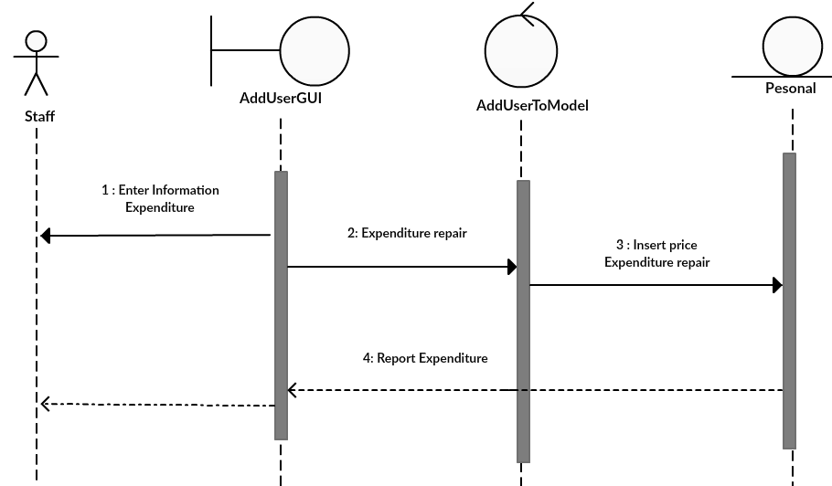

Mr.Pasin Sommung 5730213096